Using matrix models to assess temporary closure strategies for small scale fisheries

Sophie Wulfing^{1∗}, Ahilya Sudarshan Kadba¹, Mez Baker-Médard², and Easton R. White¹ ¹Department of Biological Sciences, University of New Hampshire, 03824, NH, USA

²Department of Environmental Studies, Middlebury College, Middlebury, VT 05753

- Corresponding authors: Sophie Wulfing (SophieWulfing@gmail.com) and Dr. Easton White (Easton.White@unh.edu)

1

1 1 ABSTRACT

- Mechanistic models are particularly useful for understanding life history metrics and population dynamics in

- data deficient species. Data deficiency is a relevant issue in small scale fisheries as they are generally under

- studied and underrepresented in global fishing datasets. One approach to address sustainability concerns is

- through the use of temporary spatial closures. The blue octopus (Octopus cyanea) fishery off the southwest

- coast of Madagascar is one such system that uses temporary closures to conserve an understudied species.

- As the Mozambique channel consists of strong eddies and little throughflow, the O. cyanea caught in this

- channel can be considered a distinct population as larval dispersal is largely controlled by ocean currents.

- This fishery is a key economic resource for the local community as blue octopus catch is sold by local fishers

- to international and local export markets and is a major component of fisher income. To better understand

- the biology and assess the sustainability of blue octopus, we parameterize a Levkovitch population matrix

- model using existing catch data. We found that the octopus population was experiencing a 1.8% decline

- per month at the time of data collection in 2006. However, since 2006, a number of management practices,

- including temporary closures lasting several weeks to several months have been implemented successfully.

- In line with these efforts, our model indicates that the fishery would need to close for two to three months

- annually for the fishery to be sustainable. Our model provides support to the idea that temporary closures

- have restored this population and that temporary closures provide flexibilty in management strategies that

- local communities can tailor to their economic and social needs. In addition, we were able to estimate several

- important life history metrics, such as time in each stage, stable stage distribution, reproductive value, and

- per stage survivability, that can be used in future work. Collectively, our study provides insight into the

- biology of blue octopus as well as demonstrate how temporary closures can be an effective conservation

- strategy due to the wide range of implementation options.

- Keywords: Octopus Cyanea, matrix model, small scale fisheries, Madagascar, temporary closures

- 2 INTRODUCTION

- Mechanistic models in ecology explicitly account for species life histories, behavioral, or other mechanisms

- to describe how a population or community may change over time (Briggs-Gonzalez et al., 2016). Biological

- processes are therefore hypothesized in the model, and each parameter represents these mechanisms and

- can be measured independently of the data collected. Population matrix models are a commonly used

- mechanistic model to predict future population dynamics by splitting the life history of the study organism

2

- up into a Leslie Matrix (Leslie, 1945) where a population is split up into groups of ages, and a transformation

- matrix is applied to predict what the population makeup will be in future years. However, these models

- require extremely in-depth data collection to inform each entry of the model, such as yearly survival rate

- based on age. This is not a reality for many organisms where these kind of data cannot be collected due to

- the difficulty in monitoring some species in yearly increments (Crouse et al., 1987) and for organisms that

- have long larval stages, where calculating survival probabilities for this time is nearly impossible (Gharouni

- et al., 2015).

- Instead, Lefkovitch matrices are specialized matrices are used for “structured populations” – populations

- in which individuals can be categorized based on age, stage, weight or length. Each unit of the matrix

- represents a distinct period of the organism’s life where it is subject to different environments, pressures, or

- physical attributes that would alter the survival and reproductive output at that phase, but the amount of

- time between each stage is now variable. They use demographic rates to create a projection matrix – a square

- matrix where the number of rows and columns are equivalent to the number of life stages. These models can

- be important in situations without existing long-term data, when future conditions may not be similar to the

- past, and when different scenarios or actions need to be simulated and assessed (Crouse et al., 1987; Nowlis,

- 2000; Gharouni et al., 2015). Thus, Lefkovitch matrix models play a critical role in studying the biology of

- cryptic species, and making informed conservation decisions, such as the management of small-scale fisheries.

- Worldwide, 32 million fishers make their livelihood in small-scale fisheries, a subsector in which 90 to 95%

- of fish is distributed for local consumption. These marine products are a vital source of nutrition for

- these communities (The World Bank, 2012). The southwest region of Madagascar is one such area where

- subsistence fishing is an essential component to the diet and income of the local community. The ocean

- environment off the southwest coast of Madagascar is home to a wide variety of marine life, as extensive

- tidal flats, seagrass beds, and coral reefs are all prominent biomes in the area. In fact, Madagascar has been

- calculated as a country that would benefit greatly from marine conservation given its economic reliance on

- marine harvests and the fact that it is a refuge to many marine species (Laroche et al., 1997). In the early

- 2000’s, however, Madagascar’s octopus fishery began to move from local, subsistence fishing to also selling

- catch to export markets (Humber et al., 2006). There is evidence that up to 75% of all fish caught in select

- villages is now sold to outside entities for international export (Baker-Médard, 2017).

- Locally-Managed Marine Areas (LMMAs) are defined as coastal and near-shore fisheries in which resources

- are managed almost entirely by local communities and fishery stakeholders that live in the region. Because

- management is conducted by those directly affected by the fishery, goals typically include maintaining the

- livelihood and economic and cultural goals of the local community along with environmental goals (Govan,

3

- 2010). LMMAs have grown in popularity among conservationists in small scale fisheries due to this empower-

- ment of local fishers. Because of this, LMMAs tend to have greater local participation and compliance from

- stakeholders when compared to top-down regulation from governing bodies (Katikiro et al., 2015). LMMAs

- have been shown to improve both fisheries and fisher livelihoods in Kenya (Kawaka et al., 2017), Pacific

- Islands (Govan, 2010), and in Madagascar (Mayol, 2013). In Madagascar, the use of LMMAs has increased

- significantly since 2004, and fishers in the country have seen significant improvements to fish stocks as well

- as have experienced economic benefits since (Benbow & Harris, 2011; Gilchrist et al., 2020). In order to

- protect fishing resources, these LMMAs instituted various conservation programs such as bans on certain

- types of fishing gear, implemented seasonal fishing regulations, and criminalized the harvest of endangered

- species.

- One commonly used conservation strategy in LMMAs in Madagascar are seasonal closures. These types

- of reserves have a long history of use and have been seen to successfully rehabilitate stocks (Camp et al.,

- 2015; Gnanalingam & Hepburn, 2015). For example, seasonal closures have been shown to be an effective

- conservation strategy in increasing biomass the Atlantic sea scallop (Placopecten magellanicus) fishery in

- the United States (Bethoney & Cleaver, 2019), restored natural trophic interactions in coral reef fisheries

- in Kenya (McClanahan, 2008), and successfully restored the striped marlin (Kajikia audax) stocks in Baja

- California (Jensen et al., 2010). This method is flexible, logistically simple for fishers and managers to

- understand, and mitigates the financial loss from the fishery that can be seen with permanent closures

- (Nowlis, 2000; Humber et al., 2006; Cohen & Foale, 2013; Camp et al., 2015; Gnanalingam & Hepburn,

- 2015; Oliver et al., 2015).

- Octopus are a vital part of many ocean ecosystems and, compared to other fisheries, have a unique life

- history that can lead to distinct and variable population dynamics. Cephalopods act as both predators and

- prey in an ecosystem (Rodhouse & Nigmatullin, 1996; Santos et al., 2001; Vase et al., 2021), situating them

- in a key role in food webs. Further, their abundance varies drastically with a wide range of ocean conditions

- including sea surface and bottom temperature, salinity, currents, and sediment type (Catalán et al., 2006;

- Ibáñez et al., 2019; Van Nieuwenhove et al., 2019). Compared to other exploited marine organisms, octopus

- have a short lifespan coupled with a fast reproduction rate and high fecundity which makes their populations

- more responsive to fishing pressures (Langley, 2005; Humber et al., 2006). Increased fishing pressure due to

- globalization of the blue octopus in 2003 has since added significant fishing pressure to Madagascar’s blue

- octopus populations and yield from this fishery subsequently decreased in regions of this island such as the

- southwest region of Toliara (Langley, 2005; Humber et al., 2006). However, previous temporary closures

- on the fishery resulted in population increases, indicating that this fishery has the ability to recover when

4

- fishing pressure is decreased (Humber et al., 2006; Katsanevakis & Verriopoulos, 2006; Benbow et al., 2014).

- However, right after reopening, stocks began to decline again, which has been attributed to heavy fishing

- pressure right after reopening (Humber et al., 2006; Benbow et al., 2014; Oliver et al., 2015). Octopus

- populations are therefore sensitive to both the increase and alleviation of fishing pressure and understanding

- their biology and how these population dynamics will react to changes in fishing pressure is a key component

- to effective conservation of this resource.

- Octopus cyanea, or blue octopus, is the most abundant cephalopod species in the western Indian Ocean and

- is caught in about 95% of local landings in Madagascar (Humber et al., 2006; Oliver et al., 2015). Like

- other cephalopod species, very little is known about their life history including natural death rate, larval

- survivability, and how much time this species remains in each stage of maturity. Further, age is difficult to

- determine from size alone as they have variable growth rates up to maturity (Wells & Wells, 1970; Heukelem,

- 1976; Herwig et al., 2012; Raberinary & Benbow, 2012). The O. cyanea that live in the southwest region of

- Madagascar have been shown to be genetically distinct from those outside of Madagascar (Van Nieuwenhove

- et al., 2019). This is because the ocean currents in the Channel are comprised primarily of eddies with very

- little through-flow across the Channel (Schott & McCreary, 2001; Lutjeharms et al., 2012; Hancke et al.,

- 2014). As larval dispersion is primarily controlled by ocean currents, and O. cyanea does not migrate across

- long distances, this shows that the O. cyanea in Madagascar where the data was collected can be considered

- a distinct population (Van Nieuwenhove et al., 2019).

- Size limits have been shown to be effective methods of conservation of species like Octopus cyanea that are

- harvested before maturity, and are restrictions that are easy to understand and implement in small scale

- fisheries (Nowlis, 2000). However, even though this is a conservation strategy often implemented in octopus

- fisheries, it has been shown to be less effective than instituting an overall cap on fishing effort, such as effort

- rotation or limiting the number if fishers (Emery et al., 2016). To protect this species, size limits have

- been imposed on blue octopus catch in Madagascar, but these regulations are difficult in practice, as the

- fishing method used to harvest octopus involves spearing the octopus’s den and extracting the octopus from

- the den. Blue octopus therefore typically die before size can be assessed, so octopus too small for market

- sale are typically harvested for household consumption (Humber et al., 2006). Further, the relationship

- between size and maturity stage is not strongly correlated (Raberinary & Benbow, 2012) and as a result,

- size restrictions wouldn’t necessarily protect the individuals ready to reproduce and would be difficult to

- implement in the field both due to the biology of O. cyanea and the characteristics of this small scale fishery.

- Therefore, temporary closures have been shown to be a more practical method of octopus conservation in

- that they can replenish stocks while maintaining fisher income (Benbow et al., 2014). Temporary closures

5

- provide many options for their duration and intensity (in other words, how much fishing can occur during

- a closure). However, this requires a deeper understanding of the biology and population characteristics

- of O. cyanea in this fishery in order to be properly instituted. Instituting effective temporary closures in

- octopus fisheries can be difficult due to their short lifespan, high mortality, and sensitivity to environmental

- conditions (Catalán et al., 2006; Emery et al., 2016; Ibáñez et al., 2019; Van Nieuwenhove et al., 2019).

- Lack of field data and difficulty of enforcement has also been a challenge in octopus fisheries, especially in

- Madagascar (Emery et al., 2016; Benbow et al., 2014). This indicates that a thorough understanding of

- the life history of O. cyanea and the harvest methods employed by fishers is necessary to enact meaningful

- fishing restrictions. The western Madagascar region currently institutes a yearly closure of six weeks from

- December 15 to January 31. In addition to the regional closure, individual villages institute their own local

- closures once a year, lasting from six weeks to seven months. These closures do not completely restrict

- octopus fishing, but instead institute an area where fishing is not allowed which takes up about 25% of the

- fishery’s spatial extent. Therefore, some octopus harvest does occur even during one of these closures (Aina,

- 2009; Langley, 2005; Humber et al., 2006; Benbow & Harris, 2011; Westerman & Benbow, 2014; Oliver et

- al., 2015; Rocliffe & Harris, 2015, 2016; WWF, 2017).

- In this paper, we have three goals: 1) we will fit a Levkovitch matrix to the limited available data on Octopus

- cyanea populations in southwestern Madagascar, 2) as well as create a theoretical estimation of the species’

- life history traits in different stages of its development and 3) determine the frequency and length in which

- these temporary closures should take place to maximize population health of the fishery and maximizing

- catch for the local community, and show how temporary closures can be an effective conservation strategy

- as well as demonstrate the numerous options available when deciding the length and intensity of closures.

- This study is not meant to be a current stock assessment of this fishery as local communities have taken

- numerous steps to conserve blue octopus since the time of data collection.

- 3 METHODS

- As Octopus cyanea has an extended larval phase and there is no existing data on the age structure of this

- population of octopus, we use a stage-based population matrix, otherwise known as a Lefkovitch matrix

- (Caswell, 2001). Here, the life history of the study organism is grouped by stages (Figure 1), where each unit

- of the matrix represents a distinct period of the organism’s life where it is subject to different environments,

- pressures, or physical attributes that would alter the survival and reproductive output at that phase, but the

- amount of time between each stage is variable. This would simply create different inputs for the probability of

6

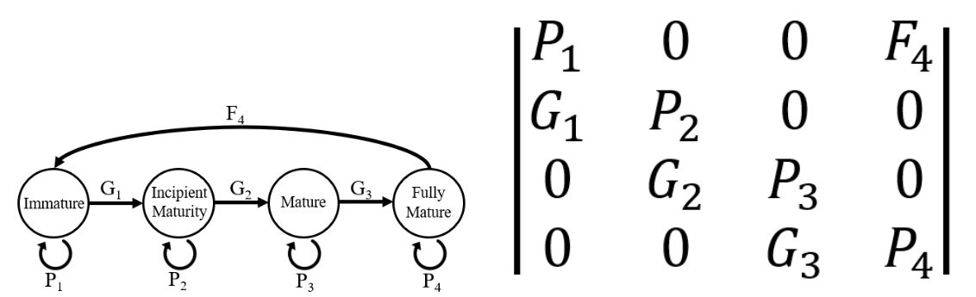

Figure 1: A graph representing the life history of O. Cyanea and the subsequent Lefkovitch Matrix where i corresponds with each of the stages of maturity (Immature, Incipient Mature, Mature, and Fully Mature individuals, respectively). P_{i} corresponds to probability of surviving and staying within a stage. G_{i} is the probability of surviving and growing to the next stage. F_{i} is the reproductive output of stage i.

- remaining in the same stage, and the growth and fecundity inputs can be based on available data. Lefkovitch

- matrices have not yet been applied to O. cyanea populations and therefore could be a useful methodology

- to understand the dynamics of this population in the western Indian Ocean to better inform management

- strategies.

- 3.1 Data

- To inform our model, we use data collected by Raberinary & Benbow (2012) from landings ranging from

- the villages of Ampasilava in the south to Andragnombala in the north which spans about 30 kilometers

- of coastline. These villages are located along the Mozambique channel, where a lack of through current

- and prevalence of eddies results in a genetically distinct population of O. cyanea (Van Nieuwenhove et al.,

- 2019). In these villages, fishers usually fish along both reef flats and deeper barrier reefs. Fishers bring catch

- onshore either for household consumption or to sell to buyers for international export. This study collected

- landing data from February 2005 to February 2006 through daily surveying fishers as they landed onshore

- within a two hour window. They separated each octopus into five age classes: immature, incipient maturity,

- maturity, full maturity, and post laying. In this paper we omit stage five, post laying, from this model as

- blue octopus only brood once, and stage five individuals therefore do not contribute to population growth.

- They recorded octopus weight, weight and length of gonads, sex, and a visual assessment of maturity class.

- A subsample of octopus were also collected for octopus length, and laboratory assessment of gonads for a

- confirmation of maturity class. They gathered this data on a total of 3,253 octopuses, and for the purposes

- of this study, we model from the 1,578 females collected. Despite there being no standardization for catch

- effort being available for this dataset, no other maturity stage study has been conducted on this population

7

- of O. cyanea and is therefore the best available data to fit a Lefkovitch matrix.
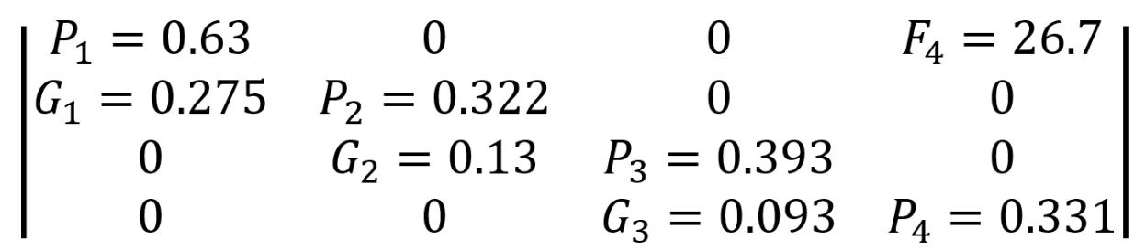

Figure 2: Stage-based population matrix calculated using Wood’s quadratic programming method and pa-rameterized using data from Raberinary and Benbow (2012).

177 3.2 Model Parameterization

- In order to parameterize this model, we use Wood’s Quadratic Programming method (Caswell, 2001). Other

- methods required longer time series than were available to us, were extremely sensitive to noise in the data,

- or simply resulted in matrices that had no reasonable biological interpretation (Caswell, 2001). One strength

- of Woods Quadratic Programming is it allows for constraining parameters to be within certain ranges. For

- example, we can constrain all parameters to be greater than zero, place zeros in the solution matrix to reflect

- Octopus cyanea biology, and ensure that all P_{i} and G_{i} parameters don’t add up to more than 1, which would

- imply that individuals in stage i are somehow multiplying themselves. The matrices then become quadratic

- equations that are solved through sum of squares minimization while also remaining within these constraints.

- We estimate a preliminary stage-based matrix model (Figure 2) based on Raberinary and Benbow (2012)

- data and calculated using the quadprog package in R (Turlach & Weingessel, 2019). We assessed model

- estimates by comparing life history values inferred from the matrix with existing literature on O. cyanea

- life history (Table 1). As all of our values calculated from the matrix fall within the known attributes of

- this species, we are confident that this model gave an accurate mechanistic description for this population’s

- underlying dynamics.

- 3.3 Model Analysis

- Eigenvalues (λ) are calculated from the matrix and future populations can be predicted by multiplying

- an initial population vector to incrementally higher powers of our matrix where the power of the matrix

- corresponds to the time length of the projection. The initial population vector used is the blue octopus data

- collected in the final month of data collection from Raberinary & Benbow (2012). This month of data is

8

- not included in the parameterization of the model as it occurred after a temporary closure that was being

- tested at the time. We perform sensitivity analysis on the population matrix and eigenvalues using the r

- package popbio (Stubben & Milligan, 2007). Further, as all of the parameters are scaled to a value between

- 0 and 1 except F₄, the different order of magnitude of these parameters have a lower proportional effect

- on the eigenvalue than F₄. To address this, we also conduct elasticity analysis using the popbio package

- (Stubben & Milligan, 2007). This allows us to identify the groups within this octopus population whose

- protection will most benefit population growth, essentially creating focus points of conservation. The results

- of sensitivity and elasticity analysis are included in the supplementary material. Other life history traits

- that can be calculated from this matrix are stable stage distribution, reproductive value of each stage, and

- per-stage survivability. We also use the R package Rage (Jones et al., 2021) to calculate the age in each

- stage, life expectancy and longevity, the age and probability of reaching maturity, and generation time of

- this population. We then used the Rage package in R to analyze various life history traits of this matrix,

- the output of which is included in the supplementary material.

- Finally, we calculate the minimum survivability increase necessary per stage to result in an increase of the

- overall population. We do this by increasing the P_{i} and G_{i} parameters by increasing percentages in each

- stage i until the overall eigenvalue (λ) became greater than one.

- 3.4 Management Scenarios

- In order to determine optimal conservation strategies, we alter the survivability of O. cyanea by different

- rates from 0-10% survival increase of the species. 10% is the maximum survival increase used because

- increasing the overall survivability of matrix by more than 10% would result in some stages reaching a

- survivability of more than 1, implying that the stage would somehow be multiplying itself within a month

- timestep. We therefore limit survival increases to a maximum of 10% to stay within biologically meaningful

- parameters. Then, we simulate different closure scenarios for each survival increase by altering the length

- of annual closures by month using the final month of data collected by Raberinary & Benbow (2012) as the

- initial population vector, this is multiplied to higher powers of the original matrix during months that are

- simulated to be “open fishing” and then when a closure was simulated, the matrix with increased survival

- was multiplied to the population for that month. We simulated these different scenarios in order to analyze

- all combinations of conservation strategies that result in stable O. cyanea populations.

9

Table 1: Existing research and information on the per-stage duration of O. cyanea. All existing estimates are from Heukelem (1973), Heukelem (1976), Guard & Mgaya (2003), Humber et al. (2006), Aina (2009). Note: Heukelem (1976) estimate the time to maturity to be 10-13 months (i.e. stages 1-3 combined). Equations used to estimate metrics from this Lefkovitch Matrix are outlined in Barot et al. (2002).

Stage | Existing Estimated Duration | Estimate from Lekfovitch | Standard Deviation of
 |  | Matrix (Months) | Estimate (Months)
Egg | 20-35 days | NA | NA
Larval | 28-56 days | NA | NA
1: Immature | No existing estimate | 2.699666 | 2.1420858
2: Incipient Maturity | No existing estimate | 1.474724 | 0.8367118
3: Mature | No existing estimate | 1.646790 | 1.0320502
4: Fully Mature | No existing estimate | 1.494651 | 0.8598431
5: Post Laying | 45-61 days | NA | NA
Post Larval Phase (Stage 1-5) | 9-18 months | NA | NA

225 4 RESULTS

- The resulting eigenvalue of our matrix is 0.982, indicating a population decline of 1.8% per month with

- fishing pressure included (Figure 3). The stable stage distribution (Table 2) shows that 65% of the makeup

- of this population is immature individuals, while actively breeding individuals (fully mature) only make up

- less than 1% of the naturally occurring population. However, the reproductive output per stage (Table 2)

- shows that on average, an individual in this fully mature population is expected to have 41 times the number

- of offspring as those in stage 1. Larval survivability of 0.0001328 is calculated by dividing our estimated

- number of larvae surviving back to stage 1 (F₄) by 201,000 - the average estimated reproductive output of

- O. cyanea by (Guard, 2009). The life expectancy of this population is calculated by the Rage package to

- be 4.06 months with a standard deviation of 2.42 months. The calculated age of maturity is 6.82 months

- with probability of reaching maturation of 0.022. The longevity of this population (the amount of months

- for only 1% of the population to remain) is 12 months with a generation time of 7.38 months.

- Changing the survivability of each stage (Figure 4) shows that immature individuals (Stage 1) would need

- the smallest amount (5%) of survival increase in order to result in overall population growth. Stage 4, on

- the other hand, requires a survivability increase of 25% in order to create a viable population.

- Our analysis of different closure scenarios (Figure 5) indicates closures two months in length or shorter may

- be ineffective in ensuring a stable population, regardless of how much these closures decreased the death

- rate of the species. Further, as our baseline growth rate is close to stable (-0.0184), it took a maximum of a

- 7.5% increase in the survivability of the population to ensure a sustainable population when utilizing three

- month closures. This analysis (Figure 5) provides all the possible combinations of increased survival rates

- and frequency of closures that will result in a stable population. Suggested changes in overall survivability

10

- range from 2-7.5%, and the ranges of frequencies of closures span from permanent closure (every month) to

- once every three months.
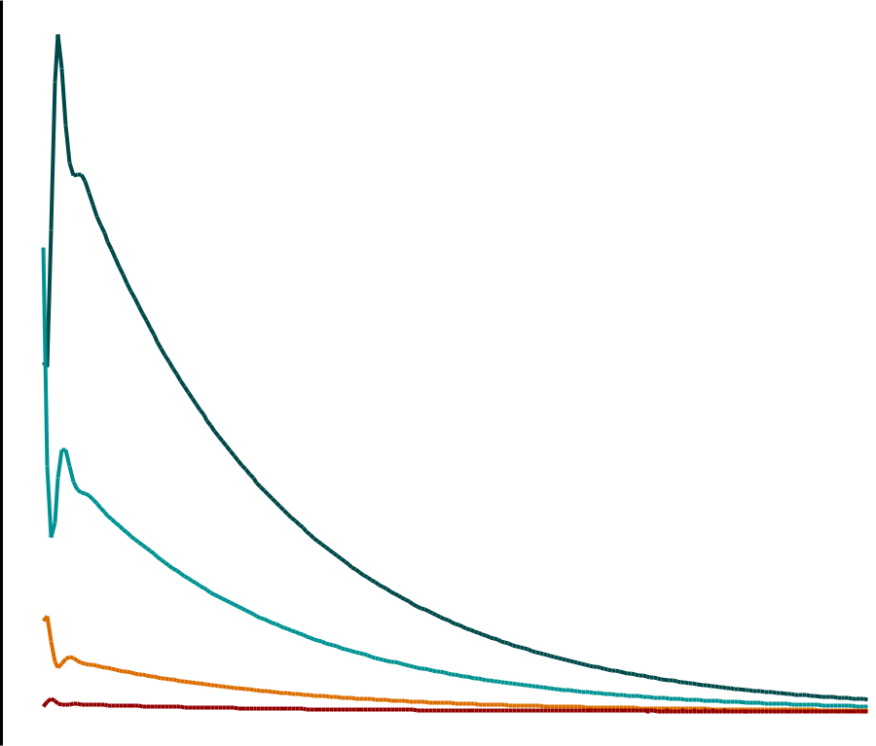

 | 150
Individuals | 100
Individuals |  |  |  |  |  |  |  |  |  | Stage 1
 |  |  |  |  |  |  |  |  |  | Stage 2
No. |  |  |  |  |  |  |  |  |  | Stage 3
No. |  |  |  |  |  |  |  |  |  | Stage 4
 | 50
 | 0
 | 2006 | 2008 | 2010 | 2012 | 2014 | 2016 | 2018 | 2020 | 2022 | 2024
 |  |  |  |  | Year

Figure 3: Projection of O. cyanea population based off of our calculated Lefkovitch matrix through the present. This does not reflect actual populations of blue octopus over time, but the predictions from our model given no action is taken to relieve fishing pressure.

248 5 DISCUSSION

- Our calculated growth rate of -0.0184 and resulting population projection supports previous reports of

- overfishing at the time of data collection in 2006 (Humber et al., 2006; Benbow et al., 2014). With this

- negative growth rate, our models suggest that, without changes to management practices, the octopus

- population may have continued to decline. In addition, according to our model, any closure less than three

- months, without additional management actions, may not be effective in conserving blue octopus stocks.

- However, given data and model limitations, we do not have a measurement of uncertainty for the growth.

- Thus, caution should be taken when considering whether the octopus population was actually in decline or

- not in 2006. We describe this limitation more below. In general, declines in octopus populations presents an

11

Table 2: Stable stage distribution and reproductive value of each stage of this blue octopus population matrix given in Figure 2. The survivability (i.e. the proportion of individuals who survive from stage i to stage i+1) in each stage includes death rate from fishing. Stages 1-4 survivability were calculated by summing up the proportion of individuals surviving and staying within a stage every month (P_{i}) and the proportion of individuals surviving and growing every month (G_{i}). Larval survivability of 0.0001328 was calculated by dividing our estimated number of larvae surviving back to stage 1 (F₄) by the average estimated reproductive output of O. cyanea.

Stage |  | Stable Stage Distribution | Reproductive Value (Left | Survivability
 |  | (Dominant Eigenvector) | Eigenvector)
1 | Immature | 0.657 | 1.000 | 0.9048003
2 | Incipient Maturity | 0.274 | 1.279 | 0.4519657
3 | Mature | 0.061 | 6.491 | 0.4859363
4 | Fully Mature | 0.009 | 41.029 | 0.3309474

30


survivalincrease | 20
Percent | 10
 | 0

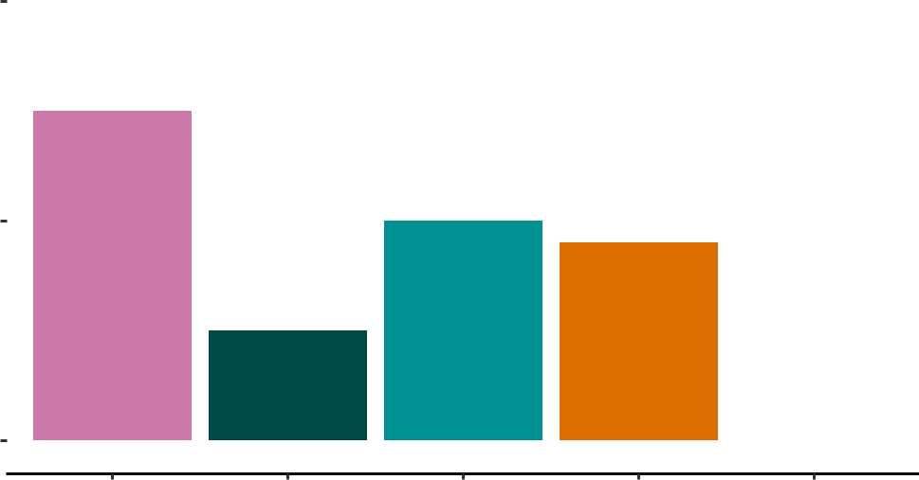

Larval | 1 | 2 | 3 | 4
Stage

Stage

Larval

1

2

3

4

Figure 4: Minimum percent of per-stage survivability change needed to create population increase. Each stage was increased by higher percentages until the eigenvalue of the overall system became greater than zero.

12

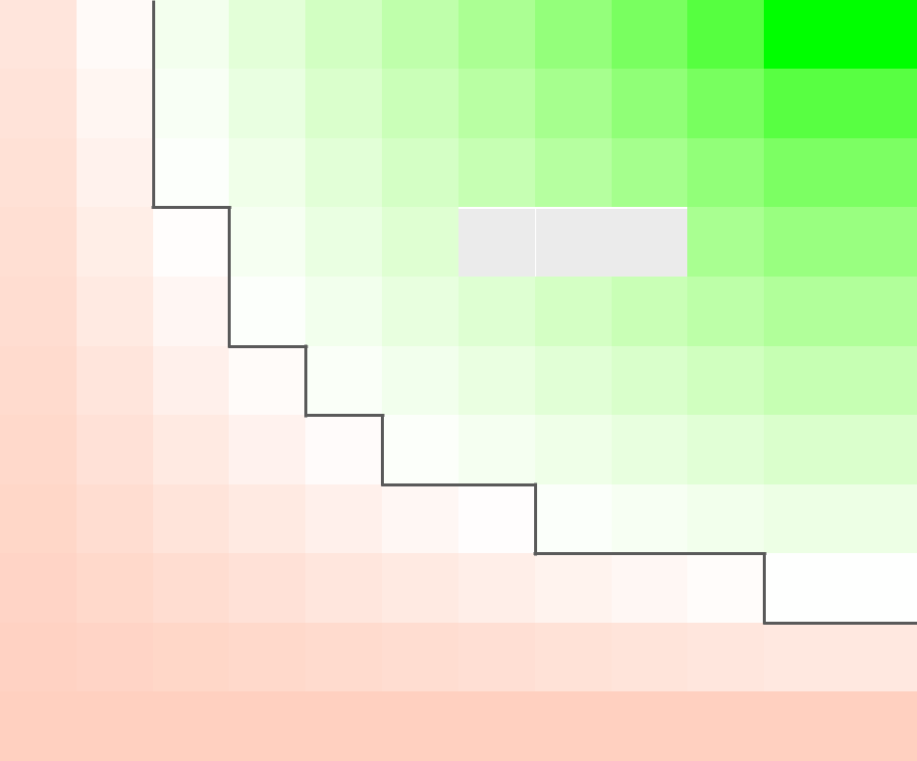

 | 10.0
insurvival | 7.5
insurvival | Population Increasing | Eigenvalue
change |  | 1.050
change | 5.0 | 1.025
Percent |  | 1.025
Percent |  | 1.000
 | 2.5

Population Decreasing

0.0

1 3 6 9 12
Length of closure (months)

Figure 5: Analysis of different management scenarios. The black line separates the scenarios that succeed in sustaining the population from the scenarios that don’t. Green and white squares indicate theoretically successful management scenarios where red refers to the strategies that will not result in overall population growth.

13

- economic issue for individual fishers as their catch will become less lucrative. Octopus population recovery

- has been shown to result in economic gains from fishers in this community (Humber et al., 2006; Benbow

- et al., 2014; Oliver et al., 2015). Further, sale prices on opening day tend to increase as buyers are typically

- guaranteed larger catch (Oliver et al., 2015).

- However, since the time of data collection, there have been a number of important changes to fisheries

- management in the region that explains the discrepancy between our model and robust octopus populations

- in many areas of Madagascar (Oliver et al., 2015; Roa-Ureta, 2022). For example, temporary closures in

- this fishery (Oliver et al., 2015) showed that extending the regional closure beyond the conventional six

- weeks increased octopus catch. Further, a 2-3 month closure was suggested for this area in 2011 in order

- to maximize catch-per unit effort (Benbow & Harris, 2011). Benbow et al. (2014) demonstrated that a

- 20-week closure had similar positive effects on octopus catch when compared to a seven month closure, yet

- resulted in less strain on fisheries management investment than the longer seven month closure. Individual

- villages also institute their own closures. These closures span 2-7 months and restrict fishing in ~20% of

- the fishery’s spatial extent, so some fishing is still allowed to occur during this time. (Rocliffe & Harris,

- 2015, 2016; WWF, 2017). Therefore, the changes to survivability suggested by our analysis is in relation

- to their overall death rate not fishing rate, indicating a need for further research on the spatial structure of

- this population. Our analysis of different closure scenarios suggests a range of the simplest actions needed

- in order to ensure sustainability of this population, and show how the relationship between closure lengths

- and their effect on mortality rates can result in multiple different temporary closures that can successfully

- conserve a fishery. Thus, despite the simplicity of our model, our findings for possible closure lengths is

- very close to those currently practiced in Madagascar and elsewhere. As we describe later, more realistic

- extensions of this model can be built to guide specific management practices.

- When implemented deliberately, establishing periodic closures is an effective and commonly-used strategy in

- sustainable fishing practices (Humber et al., 2006; Oliver et al., 2015). As Madagascar has been committed

- to protecting its marine natural resources through increasing the number of marine parks, this study serves

- to highlight some of the available strategies to make population predictions and conservation strategies with

- limited data sources (Westlund, 2017). Implementing fishing restrictions without regard for social norms

- can undermine cultural practices and in turn be detrimental to both the people and fishery, and halts the

- dissemination of traditional ecological knowledge (Okafor-Yarwood et al., 2022). For this reason, both the

- Madagascar government and scientific community has found a new emphasis on studying the complex social

- structures within the community in question in order to more effectively conserve resources along with

- peoples’ livelihoods (Billé & Mermet, 2002; Baker-Médard et al., 2021). This has been shown to increase

14

- participation in conservation practices, therefore making them more effective.

- Our model provides other information about the life history of this population as well, beyond its overall

- growth rate. As each column in the matrix represents a proportion of individuals within a stage either growing

- or staying within a stage (with the exception of the F₄ parameter), it also shows a per-stage survivability

- estimate (Table 2) and stage duration (Table 1), life history parameters on which there has been no previous

- research. However, as the immature stage has a high survivability of 90.4% and a longer duration than

- the other stages of 2.7 months, this indicates that although the fishing method employed in this region

- does not distinguish by octopus size, fishers are not bringing this smaller catch to landing due to size limits

- preventing them from selling immature individuals (Humber et al., 2006). Therefore, this could challenge

- our assumption of the data being properly stratified by size. Further, as O. Cyanea have an approximately

- one to two month larval stage (Guard & Mgaya, 2003), the fecundity parameter does not indicate the overall

- reproductive output of mature individuals, but the number of hatched offspring that will survive its larval

- stage and back the immature stage. This gives an estimation for larval survivability as female octopus have a

- fecundity ranging between 27,000 and 375,000 eggs (Guard, 2009), our model indicates that only an average

- of 26.7 individuals will survive back into immaturity, which indicates a survivability of 0.0001328. There

- is no other larval survivability estimation that currently exists for this species, which would be a useful

- further study as this could indicate a recruitment rate for this population. Further, an average lifespan of

- 4.06 months and an age of maturation of 6.82 months indicates that most individuals die before reaching

- maturation. The overall natural mortality rate of this population has been estimated to range from 0.0127

- per week (0.0552 per month) to 0.0498 per week (0.2164 per month) (Roa-Ureta, 2022). However, this was

- not included in our model of fishery closures as the local closures do not cover the full spatial extent of

- the fishery, have variable spatial extents, and some fishing continues during this time, meaning some fishing

- mortality exists during closures (Oliver et al., 2015). Instead, we compared closures to their overall effect on

- the O. cyanea mortality rate.

- The mechanistic methods used in this study allowed us to gain a baseline understanding of the growth rate

- and mortality of this population despite the limited data used to parameterize the model. Limitations of

- this study include the data collection process as this model is only parameterized using one year of data.

- Although this is not enough data to conduct a full stock assessment, this speaks to the utility of mechanistic

- modeling, where we are able to estimate population patterns and other life history traits despite this lack

- of data. A future study that repeats this method of data collection could rerun this same model with

- the updated data, and make further conclusions about the status of this fishery today. Even though data

- collections occurred daily within a two-hour window, catch was not standardized by effort and therefore

15

- there could be catch fluctuations between months that are not captured in the data. Further, as stage 1 had

- a high survival rate yet low duration, this challenges the assumption that the octopus caught are an accurate

- ratio of the octopus at each stage in the wild. Another shortcoming of this study is that the only available

- stage data for this species and region was collected in 2006, and the community of southwest Madagascar

- has implemented several strategies since that time to improve the sustainability of their fish stocks in the

- region (Humber et al., 2006; Raberinary & Benbow, 2012). Due to the time of data collection, this study

- does not reflect the current status of Octopus cyanea, nor should the findings of this study be implemented

- in current management decisions. Instead, this study outlines what biological parameters can be estimated

- from limited data using mechanistic modeling and show how temporary closures are not only an effective

- method of conservation, but also provide communities with options for effective management and these

- should be selected based off of the needs of stakeholders. As the community of southwest Madagascar has

- been involved in deciding when closures should occur and their lengths, this study serves to show the various

- options available (Benbow & Harris, 2011).

- We made a number of simplifying assumptions in our models of the biology of the study species. For example,

- our models assume that all individuals within a stage are subject to the same growth and mortality rates.

- As this study uses data collected from a large geographic range (Raberinary & Benbow, 2012), different

- individuals nesting in different regions may be subject to different selective pressures. Studies on the spatial

- variability of this population could better inform both our model and the greater understanding of how

- fishing mortality of this population compares to its natural mortality. Further, this population of blue

- octopus has been shown to exhibit spatial variability depending on their life stage. Younger individuals tend

- to live in the shallow inner zone of the reef and larger individuals, who are more able to withstand stronger

- currents, move to deeper waters for more suitable habitats for nesting (Raberinary, 2007). Our management

- scenario analysis also assumes that each lifestage would be affected equally by a closure, which could be

- challenged by the previous result that fishers are not bringing smaller catch to landing due to the size limits.

- Parameters were not extracted from a distribution curve, so adding this to future research could further

- help explain the uncertainty in octopus dynamics and better model the high variability in populations.

- Despite these limitations, the data provided is the best data available for fitting a Lefkovitch matrix to this

- species. Future extensions of this work could include applying this method to a data rich fishery, where the

- conclusions of the model can be compared to empirical data. Further, valuable future research could explore

- the dynamics of both sexes in the population (Gerber & White, 2014) as male octopus have different growth

- rates and spatial dynamics (Heukelem, 1976). A better understanding of the seasonal breeding dynamics

- of this population of blue octopus could also give better insight into the health of this fishery (White &

16

- Hastings, 2020). Cephalopod juveniles (a key life stage in understanding future population dynamics) often

- have two seasonal peaks per year, indicating biannual spawning periods (Humber et al., 2006; Katsanevakis

- & Verriopoulos, 2006). This is related to seasonal fluctuations in temperature, as cephalopod growth is

- related to environmental temperature (Domain et al., 2000). However, this relationship is subject to a lot of

- variation (Heukelem, 1976; Herwig et al., 2012). Further, as Madagascar is a tropical climate, this trend may

- be different in our region of study, as suggested by Raberinary & Benbow (2012), where all life stages of O.

- cyanea were observed year round, suggesting continuous breeding. A better understanding the seasonality

- of this population could further inform when closures should take place.

- 6 CONCLUSIONS

- With a short generation time, cephalopod species respond more quickly to new management strategies. A

- more contemporary study on the status of the octopus fishery of southwest Madagascar will paint a more

- complete picture of how this population is faring under the current fishing pressure. As a population with

- highly variable population dynamics, continuous monitoring of landings, fishing effort, and where catch is

- found is extremely valuable in understanding the status of Octopus cyanea in Madagascar. Similar data

- has been collected by Blue Ventures on this fishery since 2015 and shows there has been an improvement to

- this fishery since 2006 due to local efforts, including temporary closures. Further, this collection effort does

- not include maturity data which would improve the analysis of this study through incorporation of multiple

- years of catch data (Roa-Ureta, 2022). Finally, as the people of southwestern Madagascar are actively taking

- steps to conserve the health of their fisheries, we hope that studies such as these can serve to facilitate the

- understanding of what options are available when choosing how and when to impose fishing restrictions. We

- also hope that future work can build on our models to be more realistic for this system and produce specific

- management guidance.

- Acknowledgements - The authors would like to thank the National Science Foundation for the funding on

- this project [grant number 1923707]. We would also like to thank Dr. Sophie Benbow for not only collecting

- the data on which paper was written, but also her help in contextualizing research and answering questions

- about data collection.

- Data Availability - All supplemental material and code for this project are available at https://github.com/

- swulfing/OCyanea. All data used to parameterize this model was collected in Raberinary & Benbow (2012)

17

381 | References
382 | Aina, T. A. N. (2009). Management of octopus fishery off south west Madagascar.
383 | Baker-Médard, M. (2017). Gendering Marine Conservation: The Politics of Marine Protected Areas and
384 | Fisheries Access. Society & Natural Resources, 30 (6), 723–737. https://doi.org/10.1080/08941920.2016.
385 | 1257078
386 | Baker-Médard, M., Gantt, C., & White, E. R. (2021). | Classed conservation: Socio-economic drivers of
387 | participation in marine resource management. Environmental Science & Policy, 124, 156–162. https:
388 | //doi.org/10.1016/j.envsci.2021.06.007
389 | Barot, S., Gignoux, J., & Legendre, S. (2002). Stage-classified matrix models and age estimates. Oikos,
390 | 96 (1), 56–61. https://doi.org/10.1034/j.1600-0706.2002.960106.x
391 | Benbow, S., & Harris, A. (2011). Managing Madagascar’s octopus fisheries. Proceedingsof the workshop on
392 | Octopuscyanea fisheries, 5-6 April 2011, Toliara. Blue Ventures Conservation Report.
393 | Benbow, S., Humber, F., Oliver, T., Oleson, K., Raberinary, D., Nadon, M., Ratsimbazafy, H., & Harris, A.
394 | (2014). Lessons learnt from experimental temporary octopus fishing closures in south-west Madagascar:
395 | Benefits of concurrent closures. African Journal of Marine Science, 36 (1), 31–37. https://doi.org/10.
396 | 2989/1814232X.2014.893256
397 | Bethoney, N. D., & Cleaver, C. (2019). A Comparison of Drop Camera and Diver Survey Methods to
398 | Monitor Atlantic Sea Scallops (Placopecten magellanicus) in a Small Fishery Closure. Journal of Shellfish
399 | Research, 38 (1), 43. https://doi.org/10.2983/035.038.0104
400 | Billé, R., & Mermet, L. (2002). Integrated coastal management at the regional level: Lessons from Toliary,
401 | Madagascar. Ocean & Coastal Management, 45 (1), | 41–58. https://doi.org/10.1016/S0964-5691(02)
402 | 00048-0
403 | Briggs-Gonzalez, V., Bonenfant, C., Basille, M., Cherkiss, M., Beauchamp, J., & Mazzotti, F. (2016). Life
404 | histories and conservation of long-lived reptiles, an illustration with the American crocodile (Crocodylus
405 | acutus). Journal of Animal Ecology, 1365 (2656.12723), 12.
406 | Camp, E. V., Poorten, B. T. van, & Walters, C. J. (2015). Evaluating Short Openings as a Management Tool
407 | to Maximize Catch-Related Utility in Catch-and-Release Fisheries. North American Journal of Fisheries

18

- Management, 35 (6), 1106–1120. https://doi.org/10.1080/02755947.2015.1083495

- Caswell, H. (2001). Matrix population models: Construction, analysis, and interpretation. Sinauer Asso-

- ciates.

- Catalán, I. A., Jiménez, M. T., Alconchel, J. I., Prieto, L., & Muñoz, J. L. (2006). Spatial and temporal

- changes of coastal demersal assemblages in the Gulf of Cadiz (SW Spain) in relation to environmental

- conditions. Deep Sea Research Part II: Topical Studies in Oceanography, 53 (11-13), 1402–1419. https:

- //doi.org/10.1016/j.dsr2.2006.04.005

- Cohen, P. J., & Foale, S. J. (2013). Sustaining small-scale fisheries with periodically harvested marine

- reserves. Marine Policy, 37, 278–287. https://doi.org/10.1016/j.marpol.2012.05.010

- Crouse, D. T., Crowder, L. B., & Caswell, H. (1987). A Stage-Based Population Model for Loggerhead Sea

- Turtles and Implications for Conservation. Ecology, 68 (5), 1412–1423. https://doi.org/10.2307/1939225

- Domain, F., Jouffre, D., & Caverivière, A. (2000). Growth of Octopus Vulgaris from tagging in Senegalese

420 | waters. Journal of the Marine Biological Association of the United Kingdom, 80 (4), 699–705. https:
421 | //doi.org/10.1017/S0025315400002526
422 | Emery, T. J., Hartmann, K., & Gardner, C. (2016). Management issues and options for small scale
423 | holobenthic octopus fisheries. Ocean & Coastal Management, 120, 180–188. https://doi.org/10.1016/
424 | j.ocecoaman.2015.12.004
425 | Gerber, L. R., & White, E. R. (2014). Two-sex matrix models in assessing population viability: When do male
426 | dynamics matter? Journal of Applied Ecology, 51 (1), 270–278. https://doi.org/10.1111/1365-2664.12177
427 | Gharouni, A., Barbeau, M., Locke, A., Wang, L., & Watmough, J. (2015). Sensitivity of invasion speed
428 | to dispersal and demography: An application of spreading speed theory to the green crab invasion on
429 | the northwest Atlantic coast. Marine Ecology Progress Series, 541, 135–150. https://doi.org/10.3354/
430 | meps11508
431 | Gilchrist, H., Rocliffe, S., Anderson, L. G., & Gough, C. L. A. (2020). Reef fish biomass recovery within
432 | community-managed no take zones. Ocean & Coastal Management, 192, 105210. https://doi.org/10.
433 | 1016/j.ocecoaman.2020.105210
434 | Gnanalingam, G., & Hepburn, C. (2015). Flexibility in temporary fisheries closure legislation is required to

19

- maximise success. Marine Policy, 61, 39–45. https://doi.org/10.1016/j.marpol.2015.06.033

- Govan, H. (2010). Status and potential of locally-managed marine areas in the South Pacific: Munich

- Personal RePEc Archive, 23828.

- Guard, M. (2009). Biology and fisheries status of octopus in the Western Indian Ocean and the Suitability

- for marine stewardship council certification (p. 22). e United Nations Environment Programme.

- Guard, M., & Mgaya, Y. D. (2003). The Artisanal Fishery for Octopus cyanea Gray in Tanzania. AMBIO:

- A Journal of the Human Environment, 31 (7), 528–536. https://doi.org/10.1579/0044-7447-31.7.528

- Hancke, L., Roberts, M. J., & Ternon, J. F. (2014). Surface drifter trajectories highlight flow pathways

- in the Mozambique Channel. Deep Sea Research Part II: Topical Studies in Oceanography, 100, 27–37.

- https://doi.org/10.1016/j.dsr2.2013.10.014

- Herwig, J. N., Depczynski, M., Roberts, J. D., Semmens, J. M., Gagliano, M., & Heyward, A. J. (2012).

- Using Age-Based Life History Data to Investigate the Life Cycle and Vulnerability of Octopus cyanea.

- PLoS ONE, 7 (8), e43679. https://doi.org/10.1371/journal.pone.0043679

- Heukelem, W. F. V. (1973). Growth and life-span of Octopus cyanea (Mollusca: Cephalopoda)*. Journal

- of Zoology, 169 (3), 299–315. https://doi.org/10.1111/j.1469-7998.1973.tb04559.x

- Heukelem, W. F. V. (1976). Growth, bioenergetics, and life-span of Octopus cyanea and Octopus maya. A

- Dissertation Submitted to the Graduate Division of the University of Hawaii in Partial Fulfillment of the

- Requirements for the Degree of Doctor of Philosophy in Zoology, 232.

- Humber, F., Harris, A., Raberinary, D., & Nadon, M. (2006). Seasonal Closures of No-Take Zones to

- promote A Sustainable Fishery for Octopus Cyanea (Gray) in South West Madagascar. Blue Ventures

- Conservation Report.

- Ibáñez, C. M., Braid, H. E., Carrasco, S. A., López-Córdova, D. A., Torretti, G., & Camus, P. A. (2019).

- Zoogeographic patterns of pelagic oceanic cephalopods along the eastern Pacific Ocean. Journal of

- Biogeography, 46 (6), 1260–1273. https://doi.org/10.1111/jbi.13588

- Jensen, O. P., Ortega-Garcia, S., Martell, S. J. D., Ahrens, R. N. M., Domeier, M. L., Walters, C. J., &

- Kitchell, J. F. (2010). Local management of a “highly migratory species”: The effects of long-line closures

- and recreational catch-and-release for Baja California striped marlin fisheries. Progress in Oceanography,

20

- 86 (1-2), 176–186. https://doi.org/10.1016/j.pocean.2010.04.020

- Jones, O. R., Barks, P., Stott, I. M., James, T. D., Levin, S. C., Petry, W. K., Capdevila, P., Che-Castaldo,

- J., Jackson, J., Römer, G., Schuette, C., Thomas, C. C., & Salguero-Gómez, R. (2021). Rcompadre

- and rage - two R packages to facilitate the use of the COMPADRE and COMADRE databases and

- calculation of life history traits from matrix population models. bioRxiv, 2021.04.26.441330. https:

- //doi.org/10.1101/2021.04.26.441330

- Katikiro, R. E., Macusi, E. D., & Ashoka Deepananda, K. H. M. (2015). Challenges facing local communities

- in Tanzania in realising locally-managed marine areas. Marine Policy, 51, 220–229. https://doi.org/10.

- 1016/j.marpol.2014.08.004

- Katsanevakis, S., & Verriopoulos, G. (2006). Seasonal population dynamics of Octopus vulgaris in the

472 | eastern Mediterranean. ICES Journal of Marine Science, 63 (1), 151–160. https://doi.org/10.1016/j.
473 | icesjms.2005.07.004
474 | Kawaka, J. A., Samoilys, M. A., Murunga, M., Church, J., Abunge, C., & Maina, G. W. (2017). Developing
475 | locally managed marine areas: Lessons learnt from Kenya. Ocean & Coastal Management, 135, 1–10.
476 | https://doi.org/10.1016/j.ocecoaman.2016.10.013
477 | Langley, J. (2005). The 2004-2005 census of Andavadoaka, southwest Madagascar.
478 | Laroche, J., Razanoelisoa, J., Fauroux, E., & Rabenevanana, M. W. (1997). The reef fisheries surrounding
479 | the south-west coastal cities of Madagascar. Fisheries Management and Ecology, 4 (4), 285–299. https:
480 | //doi.org/10.1046/j.1365-2400.1997.00051.x
481 | Leslie, P. H. (1945). On the Use of Matrices in Certain Population Mathematics. 31.
482 | Lutjeharms, J. R. E., Biastoch, A., Van der Werf, P. M., Ridderinkhof, H., & De Ruijter, W. P. M. (2012).
483 | On the discontinuous nature of the Mozambique Current. South African Journal of Science, 108 (1/2),
484 | 5 pages. https://doi.org/10.4102/sajs.v108i1/2.428
485 | Mayol, T. (2013). Madagascar’s nascent locally managed marine area network. Madagascar Conservation
486 | & Development, 8 (2), 91–95. https://doi.org/10.4314/mcd.v8i2.8
487 | McClanahan, T. R. (2008). Response of the coral reef benthos and herbivory to fishery closure management
488 | and the 1998 ENSO disturbance. Oecologia, 155 (1), 169–177. https://doi.org/10.1007/s00442-007-0890-

21

- 0

- Nowlis, J. S. (2000). Short- and long-term effects of three fishery-management tools on depleted fisheries.

- BULLETIN OF MARINE SCIENCE, 66 (3), 12.

- Okafor-Yarwood, I., Kadagi, N. I., Belhabib, D., & Allison, E. H. (2022). Survival of the Richest, not the

- Fittest: How attempts to improve governance impact African small-scale marine fisheries. Marine Policy,

- 135, 104847. https://doi.org/10.1016/j.marpol.2021.104847

- Oliver, T. A., Oleson, K. L. L., Ratsimbazafy, H., Raberinary, D., Benbow, S., & Harris, A. (2015). Positive

- Catch & Economic Benefits of Periodic Octopus Fishery Closures: Do Effective, Narrowly Targeted Ac-

- tions “Catalyze” Broader Management? PLOS ONE, 10 (6), e0129075. https://doi.org/10.1371/journal.

- pone.0129075

- Raberinary, D. (2007). Periode de ponte du poulpe (Octopus cyanea) D’Andavadoaka dans la region sud oest

- de Madagascar. Blue Ventures Conservation.

- Raberinary, D., & Benbow, S. (2012). The reproductive cycle of Octopus cyanea in southwest Madagascar

- and implications for fisheries management. Fisheries Research, 125–126, 190–197. https://doi.org/10.

- 1016/j.fishres.2012.02.025

- Roa-Ureta, R. H. (2022). Stock Assessment of Octopus cyanea in the fishery of Southwest Madagascar, 2015

- to 2020 (p. 26). Blue Ventures.

- Rocliffe, S., & Harris, A. (2015). Scaling success in octopus fisheries management in the Western Indian

- Ocean. Proceedings of the workshop, 3-5 December 2014, Stone Town, Zanzibar. Blue Ventures.

- Rocliffe, S., & Harris, A. (2016). Blue Ventures Report: Experiences of periodic closures in small-scale

- invertebrate fisheries April 2016. Blue Ventures.

- Rodhouse, P. G., & Nigmatullin, M. (1996). Role as consumers. Royal Society Publishing, 20. https:

- //doi.org/10.1098/rstb.1996.0090

- Santos, M. B., Clarke, M. R., & Pierce, G. J. (2001). Assessing the importance of cephalopods in the diets of

- marine mammals and other top predators: Problems and solutions. Fisheries Research, 52 (1-2), 121–139.

- https://doi.org/10.1016/S0165-7836(01)00236-3

22

- Schott, F. A., & McCreary, J. P. (2001). The monsoon circulation of the Indian Ocean. Progress in

- Oceanography, 51 (1), 1–123. https://doi.org/10.1016/S0079-6611(01)00083-0

- Stubben, C. J., & Milligan, B. G. (2007). Estimating and analyzing demographic models using the popbio

- package in r. Journal of Statistical Software, 22 (11).

- The World Bank. (2012). HIDDEN HARVEST-The Global Contribution of Capture Fisheries (66469-

- GLB). The World Bank. https://documents1.worldbank.org/curated/en/515701468152718292/pdf/

- 664690ESW0P1210120HiddenHarvest0web.pdf

- Turlach, B. A., & Weingessel, A. (2019). Quadprog: Functions to solve quadratic programming problems.

- https://CRAN.R-project.org/package=quadprog

- Van Nieuwenhove, A. H. M., Ratsimbazafy, H. A., & Kochzius, M. (2019). Cryptic diversity and limited

- connectivity in octopuses: Recommendations for fisheries management. PLOS ONE, 14 (5), e0214748.

- https://doi.org/10.1371/journal.pone.0214748

- Vase, V. K., Koya, M. K., Dash, G., Dash, S., Sreenath, K. R., Divu, D., Kumar, R., Rahangdale, S.,

- Pradhan, R. K., Azeez, A., Sukhdhane, K. S., & Jayshree, K. G. (2021). Acetes as a Keystone Species

- in the Fishery and Trophic Ecosystem Along Northeastern Arabian Sea. Thalassas: An International

- Journal of Marine Sciences, 37 (1), 367–377. https://doi.org/10.1007/s41208-020-00276-y

- Wells, M. J., & Wells, J. (1970). Observations on the feeding, growth rate and habits of newly settled Octopus

- Cyanea. Journal of Zoology, 161 (1), 65–74. https://doi.org/10.1111/j.1469-7998.1970.tb02170.x

- Westerman, K., & Benbow, S. (2014). The Role of Women in Community-based Small-Scale Fisheries

- Management: The Case of the South West Madagascar Octopus Fishery. Western Indian Ocean Journal

- of Marine Science, 12 (2), 119–132.

- Westlund, L. (Ed.). (2017). Marine protected areas: Interactions with fishery livelihoods and food security.

- Food and Agriculture Organization of the United Nations.

- White, E. R., & Hastings, A. (2020). Seasonality in ecology: Progress and prospects in theory. Ecological

- Complexity, 44, 100867. https://doi.org/10.1016/j.ecocom.2020.100867

- WWF. (2017). Abundant octopus on the Mahafaly coast. World Wildlife Fund.

23

